 ­­

Website Design Documentation

By Ramon Bellett

­­

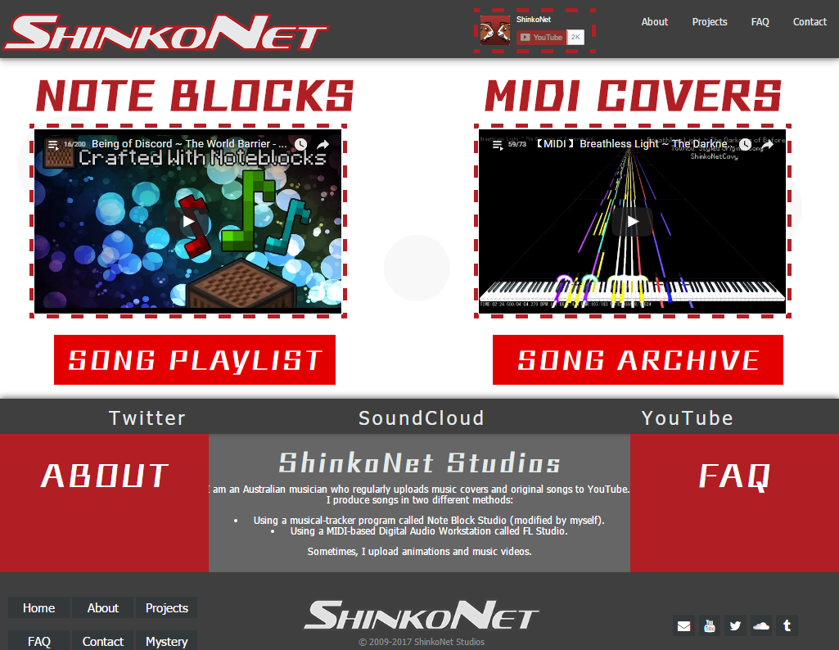

­­­­

## Purpose

To create a website showcasing my Multimedia work, especially my YouTube channel as a whole, to attract in more viewers and gain subscribers. It should inform the visitor my featured work on the front page, being easily accessible and emphasized. I will also use this website to address frequently-asked-questions on my channel, state announcements concerning my channel, and a contact page for businesses and song requests. The website’s aim is to persuade the user to subscribe.

## Target audience

* Gamers, especially people who play/have heard of Minecraft, Pokémon or the Touhou Project.
* People who watch Anime.
* Subscribers of my channel.
* People who watch YouTube.
* Musicians, especially people who use MIDIs to create remixes of songs.
* Note block song composers.
* The people who fall under these categories will probably be majority male, aged 14-25, so the webpage design will be adapted accordingly.

## Delivery Platform

The platform is the internet. The constraints are having the webpage fit into a 1366*768 resolution, low on bandwidth consumption for images, and using a Sans-serif web-compatible font. Since this channel is used specifically for showcasing YouTube videos, most of the page will have video media that links outside of the site, allowing there to have less data hosted locally.

## Research

Investigating three different portfolio websites, with pros and cons of each.

|  |  |  |
| --- | --- | --- |
| Website | Pros | Cons |
| Grande1899  ../../../../../../../../Users/rbellett/Desktop/Screen%20Shot%2020 | Highly relevant in content, such as advertising a YouTube channel similar to mine. It shares nearly the same target audience. It features a good navigation bar. | The YouTube links are not ordered evenly, throwing off the balance of the site. The header is not a good image, as it has a skewed perspective and is simply a screenshot from Minecraft. |
| AntVenom  ../../../../../../../../Users/rbellett/Desktop/Screen%20Shot%2020 | The colour scheme of the site fits in with the logo. Image slider is used for featured videos, and the latest videos are neatly organized under. There is an information section at the middle-left, informing the user about the website. | The navigation bar is a bit squashed. The thumbnails are a bit too large and do not fit with the colour scheme. There should be more information about the channel inside the divisions beneath the videos, as it shows only the “extra” activities AntVenom does. |
| Ownage Pranks  ../../../../../../../../Users/rbellett/Desktop/Screen%20Shot%2020 | The focus of the website is drawn to the characters, as the main point of this channel is his voice acting of these characters. Below the logo is a subscriber counter, a unique feature. There are links to latest videos and social media as soon as you scroll down the page, as well as featured videos sorted into categories. | It looks too much like a company website / TV Show website than a YouTube channel, due to the focus being the characters. There is a lot of clutter in the navigation bar, as it spans two lines (including a subscriber count and an email list below it.) It uses a 1024x768 resolution with the mobile site looking completely different. |

## Brainstorming

This is the initial planning for the webpage, in the form of a mind map.

## ../../../../../../../../Users/rbelle

## software

The programs I will use to make this website are Adobe Dreamweaver CS6, Adobe Photoshop CS6, Google Chrome, Firefox and Safari.

The requirements for the website to run correctly: A computer that can browse modern websites and support modern browsers.

## storyboard

This is the proposed design of the website, namely the front page design and the overall CSS design.

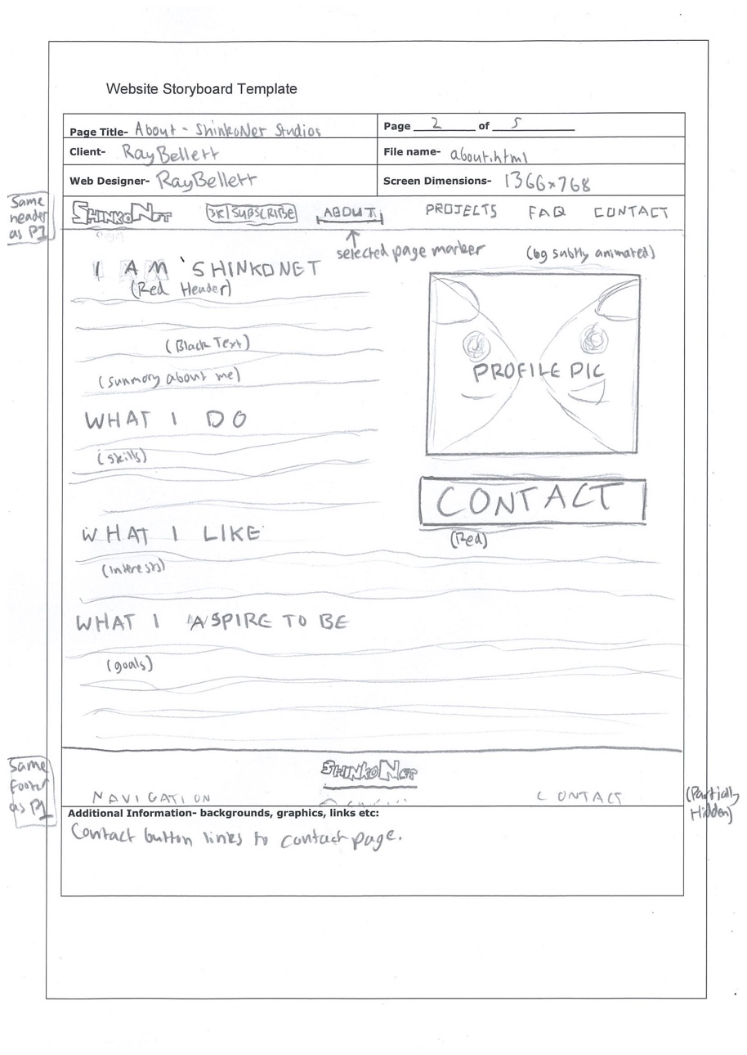**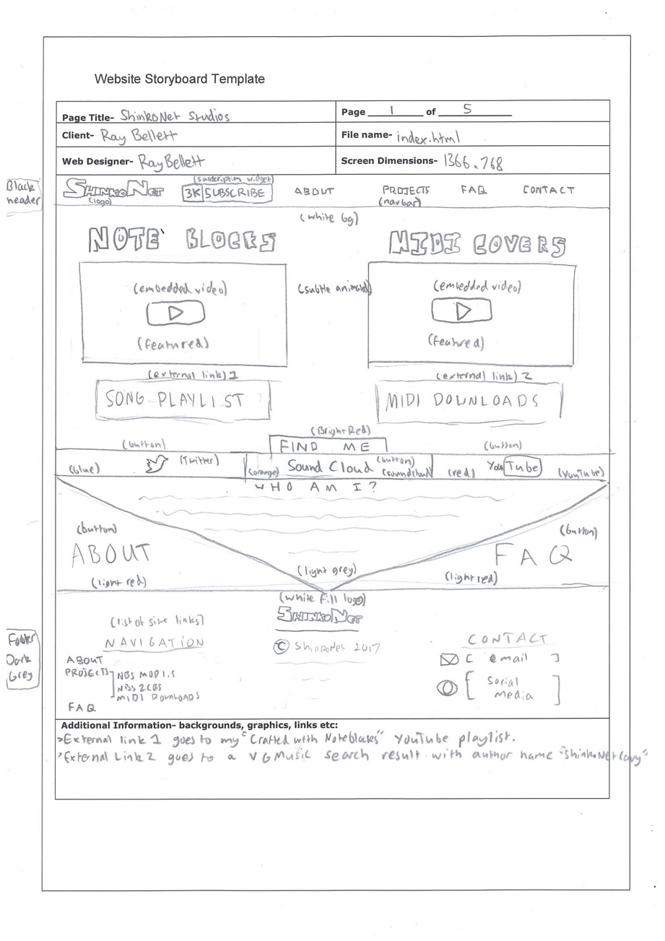Page 1. (Home)**  **Page 2 (About)**

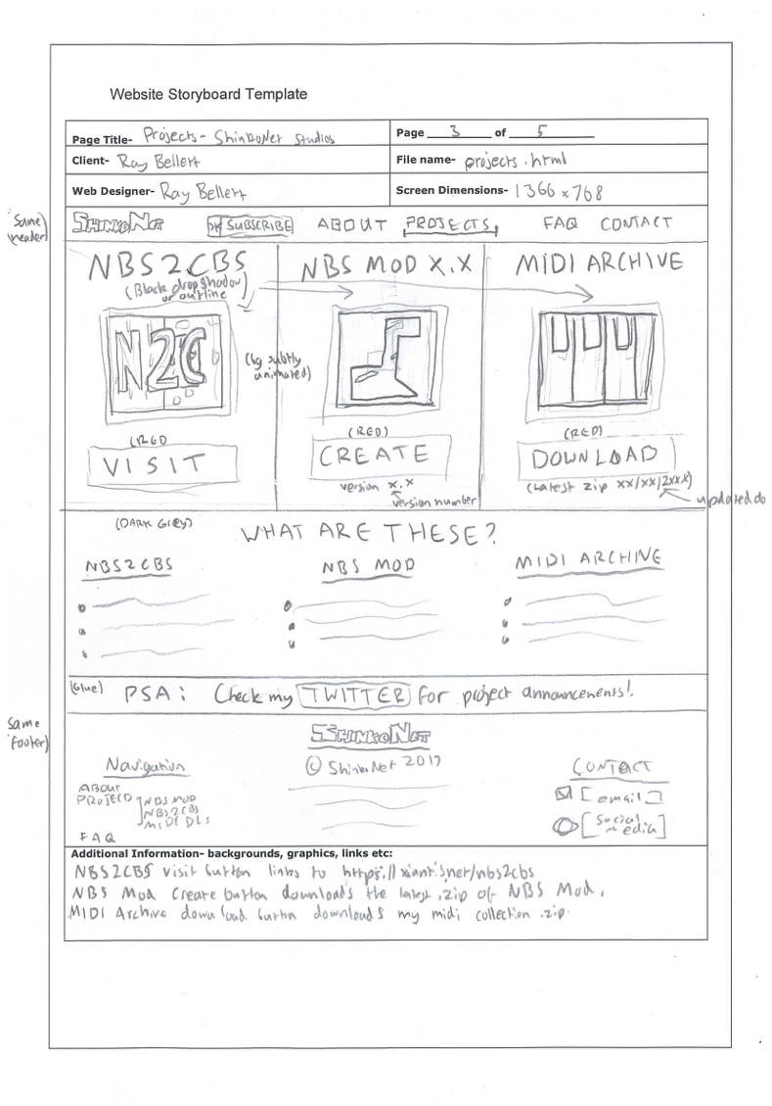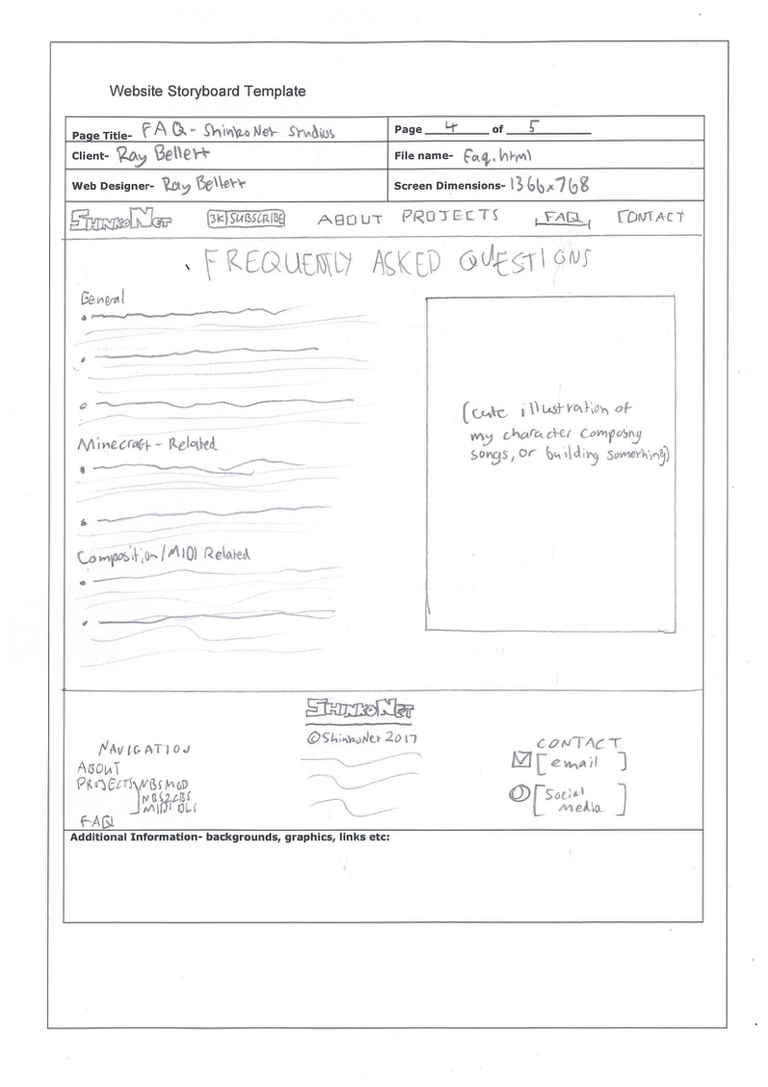**Page 3. (Projects) Page 4. (FAQ)**

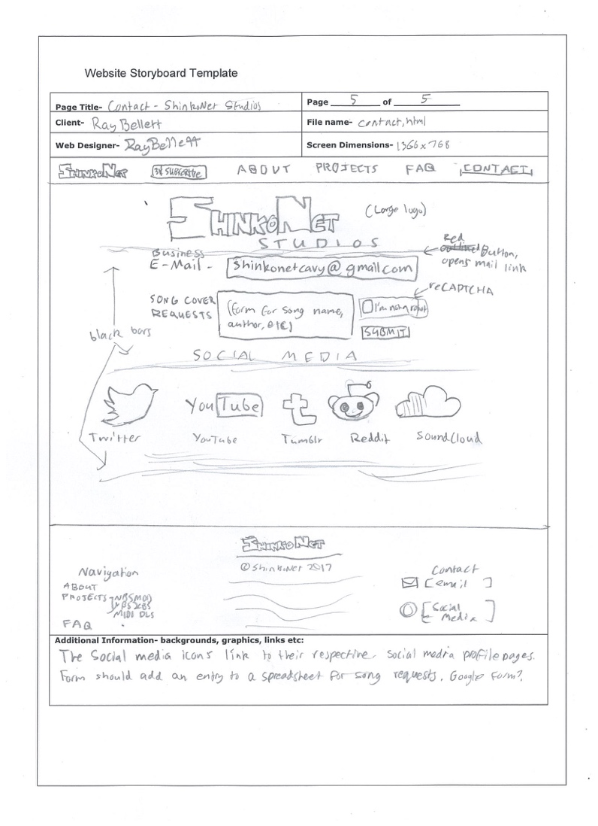**Page 5. (Contact)**

## Content

On Page 1:

* “Who Am I?”
  + I am ShinkoNet - an Australian musician who regularly uploads music covers to YouTube.
  + I produce songs in two different methods:
    - Using a musical-tracker program called Note Block Studio (modified by myself).
    - Using a MIDI-based Digital Audio Workstation called FL Studio.
  + Sometimes, I upload animations and music videos.

On Page 2:

* “I AM SHINKONET”
  + A Multimedia student who uploads music, animations and parodies.
* “WHAT I DO”
  + You might know me from creating remixes and note block covers of popular video games.
  + My most popular remixes include songs from Undertale, Osu, Five Nights at Freddy’s, and Touhou.
  + I have helped develop the music-tracker program Note Block Studio, and the Minecraft structure generating tool called NBS2CBS.
* “WHAT I LIKE”
  + I love Japanese food. My favourite meals include Okonomiyaki, Ramen and Mochi. Thus, my YouTube channel has been heavily influenced with eastern culture.
  + I enjoy creating animations, done in Flash.
  + I like drawing illustrations of my original characters in my free time.
* “WHAT I ASPIRE TO BE”
  + A 3D Animator - By the time I graduate, I wish to be hired into a local animation studio and work my way up from there.
  + It’s going to be very difficult, but working at Pixar or DreamWorks is my life-long goal.
  + In case I cannot become an animator, I want to work in a video game studio, providing assets such as music, art and models.

On Page 3:

* “WHAT ARE THESE?”
  + NBS2CBS
    - A tool to export note block songs into Minecraft.
    - It is the schematic-exporting engine built into my music-tracker program NBS Mod.
    - This program removes nearly all of the limitations in place when creating note block songs.
  + NBS Mod
    - A modified, advanced version of the popular Minecraft Note Block Studio.
    - It includes performance improvements, better sounds and less limitations than the original.
    - I use this tool to create all of my note block songs.
  + MIDI Archive
    - This is an archive containing all of the songs I have covered, in the .MID file format.
    - All of the files are free to use for remixing, as long as they are properly credited.
    - This archive is regularly updated. Check the README for recent song additions.

On Page 4:

* “General”
  + What kind of songs do you upload onto your channel?
    - I try and keep my uploaded songs into three categories: Anime songs, Video Game songs and Original songs. Usually, I am experimenting when I deviate from these genres.
  + Can I use your songs in my videos?
    - Yes, any song I upload, even originals, can be used for your videos as long as you clearly credit me in the video or description.
  + How can I request a song for you to cover?
    - You can request a song by going to my contact page and filling in the form. However, there is no guarantee I will cover that song.
  + Do you do song commissions?
    - Yes, please email me at [ShinkoNetCavy@gmail.com](mailto:ShinkoNetCavy@gmail.com) and state the song you want me to create, what style, and any other comments.
      * Note Block song covers are $5 each.
      * MIDI covers are $10 each.
      * Original songs are $20, and include all royalties.
* “Minecraft Related”
  + Can I have a tutorial on how to make this song?
    - Sure! Some time in the future, I will create tutorials on how MIDI sequencing works and how to sequence a song, the techniques of properly editing and transcribing this MIDI file into Note Block Studio, and the refining process and note block-specific effects I use on my songs.
    - I don’t use note blocks themselves when making my songs. I solely use command blocks. So, a Redstone-based tutorial is impossible.
  + Can I have the NBS file?
    - I don’t share the source files for my songs. An exception to this are the songs I bundled into the NBS Mod downloads.
    - I might set up a Bandcamp sometime soon, to sell my songs.
  + Where’s a world download?
    - I will supply the structure NBT files for my songs as soon as I fully release NBS2CBS. The method will be easier and more convenient than a world download.
  + When will NBS2CBS be released?
    - Simple answer: When all the bugs are ironed out, and when it works on Minecraft 1.12.
    - Technical answer: It will be released when the current lag-issues concerning the program are fixed, mainly the lag spike when loading the structures and the gigantic MCEdit schematic importing times. Structure blocks fix these issues, but it’s taking a while to implement.
  + How do you get a visualizer for your songs? Why are they in stereo? How can you get over the two octave limit? Why are there so many instruments?
    - These are all features of NBS2CBS; the program my team is developing to export songs into Minecraft.
* “MIDI Related”
  + What is the program you are using to display your MIDIs?
    - MIDITrail yossiepon mod, 2D piano view, camera rolled 90 degrees and above the keyboard, and a luma key effect for the background. It also has a custom note scrolling speed in it’s config files.
  + How do you make your MIDIs?
    - I use FL Studio. Using the Playlist feature, I have the entire MIDI in a single pattern, usually. I then have the original song as an audio object lined up with the MIDI pattern to sync over the song when I press Play.
    - I also use plugins such as Parametric EQ 2, Wave Candy and stereo isolation to help me hear the notes.
    - I stream myself creating my MIDIs, you can find the archived stream of that song’s creation in most of my recent MIDI covers.
  + What plugins do you use?
    - I use many plugins that Nintendo or indie game dev ZUN uses, and the lists of those can be found HERE and HERE.

## Site map

## 

## Colour scheme

The website will use Black, Dark Grey, White and Red.

Black and dark grey will be used for headers and bars. Red will be used to highlight buttons and text of interest. White will be used for the background, and text over black headers and bars.

## Feedback

During development, I received anonymous feedback on the website to improve its looks.

|  |  |
| --- | --- |
| **Pros:** | **Cons:** |
| Looks good | Too much going on. |
| Nice colour scheme. | Needs more to the website doesn’t have a lot on it. |
| The navigation bar is very professional | I think having bubbles floating distracts from the purpose of the website |
| The overall layout of this website is very professional and looks very well put together | The formatting can have problems when the window isn’t scaled to the size that you are used to working with.  The colour scheme looks nice but I find the bubbles to be very distracting and unneeded.  hey look cool but take out the professionalism of what you are trying to present to the audience.  I don’t like the drop shadow that is on the left side of your website as it makes it seem like your website doesn’t scale properly to your website |
| Very nice how it has fluoro themes and I like the videos.  I love how I can easily subscribe. | If a beginner played Minecraft, and didn’t know how to use note blocks, I wonder if there should be a tutorial video somewhere in the website. |
| Good colour scheme. The video border matches the aesthetic of the site nicely | The site looks a bit dated and the use of so many different fonts looks a bit distracting |
| The colour consistency is well flowing. | The actual page is too ‘popping’ literally everything is jumping at you and is quite annoying. Also, the fonts are inconsistent and doesn’t create a natural flow to the page. |

From this feedback, I made the bubble animation less distracting, reduced the number of fonts used, and interchanged colour elements.

## Evaluation

Creating the content for the website was relatively easy, as I had developed my interests and experiences around my YouTube channel. For example, the comments I receive in my videos were the basis of the FAQ page. The videos I create shaped my interests in the About page.

Due to this website’s purpose of “selling” my YouTube channel to a passing audience by showing them a portfolio of my work, the front page is heavily directed towards showing my featured YouTube videos and ways of contacting me. There are multiple links throughout the site that link to either a social media page or the contact page, and are highlighted using the color scheme.

People that know me on YouTube only, and visit my website because they are already a subscriber, are expected to be a significant amount of the traffic to the website. Because of this, the content in some pages, mainly the FAQ, was written to target and inform the ones who are subscribed.

The Gunning Fox Index of the content on the page is ranked to 8. This is the best possible match for the 14+ target audience, as it is the reading level for 8th grade.

There were many technological difficulties when creating the website, due to it being made from scratch. While I was trying to incorporate external code such as the animated navigation bar, trying to fit it with the logo and subscription button proved a challenge. A similar issue occurred when creating the buttons and text for the footer. Positioning elements onto a page, making sure they were balanced symmetrically, and properly displaying them in multiple browsers, was a task I needed to work with the whole time.

If I was to start this project again, I would make myself more familiar with the differences and uses of classes, IDs and inline CSS tags before constructing the website. It would make the code less hard to work with.

The industry roles I had to undertake when creating the website were market researching, website research and design, graphic design, coding the website, testing, and quality-checking the website.

During the production of the website, I reduced my risk of obtaining RSI by bringing in a mechanical keyboard. This kind of keyboard is less strenuous on the fingers and is proven to be better suited for the hands than a flat keyboard, such as the ones in the workroom. I also attempted to maintain a good posture while I worked.

In total, creating this portfolio website helped me hone my skills in creating informational and impactful written pieces, coding in CSS and HTML, and is good practice for familiarizing and improving on the design process that I have followed in the creation for most of my work in the course.